**Name: Chaitanya Darade**

**ID: 801135814**

**MILESTONE–4**

1. Screenshots of all views of your application displayed in your browser.

* **Index Page**

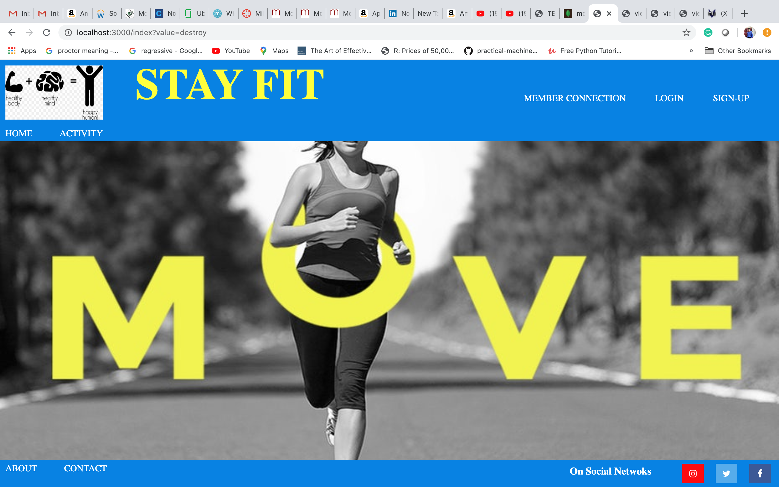

* **About Page**

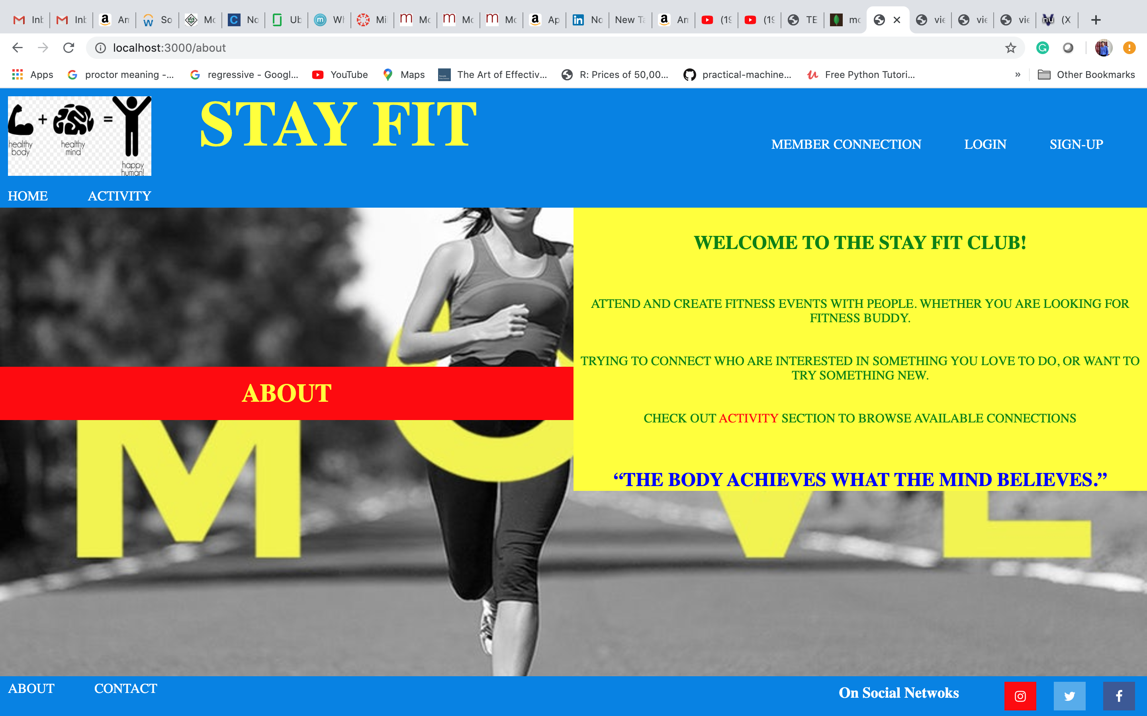

* **Contact Page**

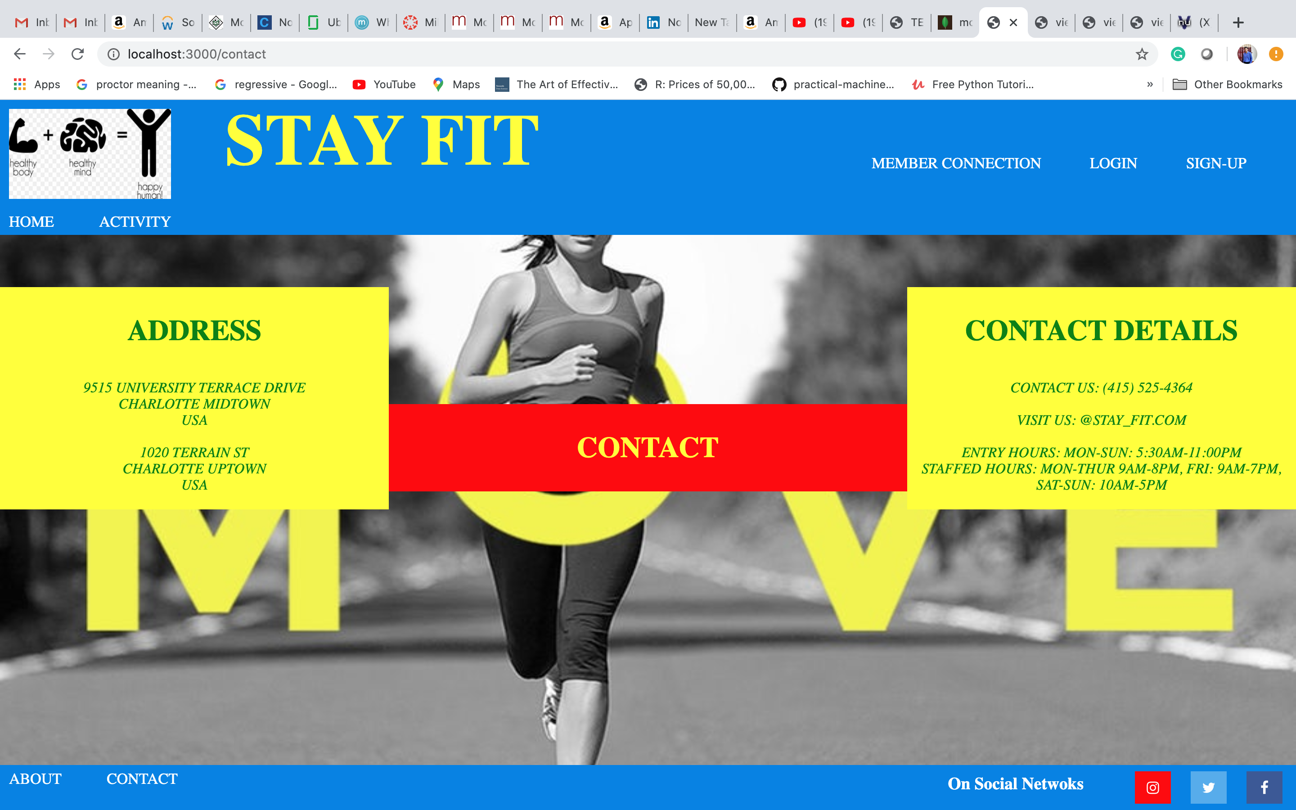

* **Login Page**

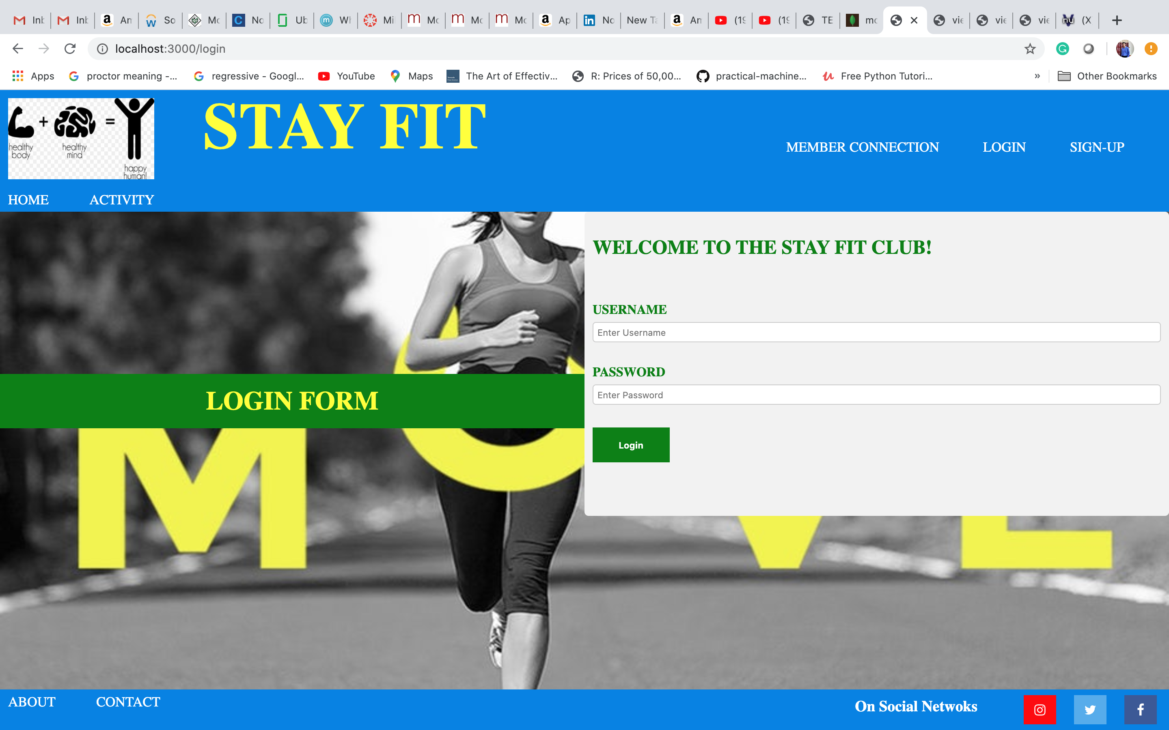

* **Client (Empty Connections) page**

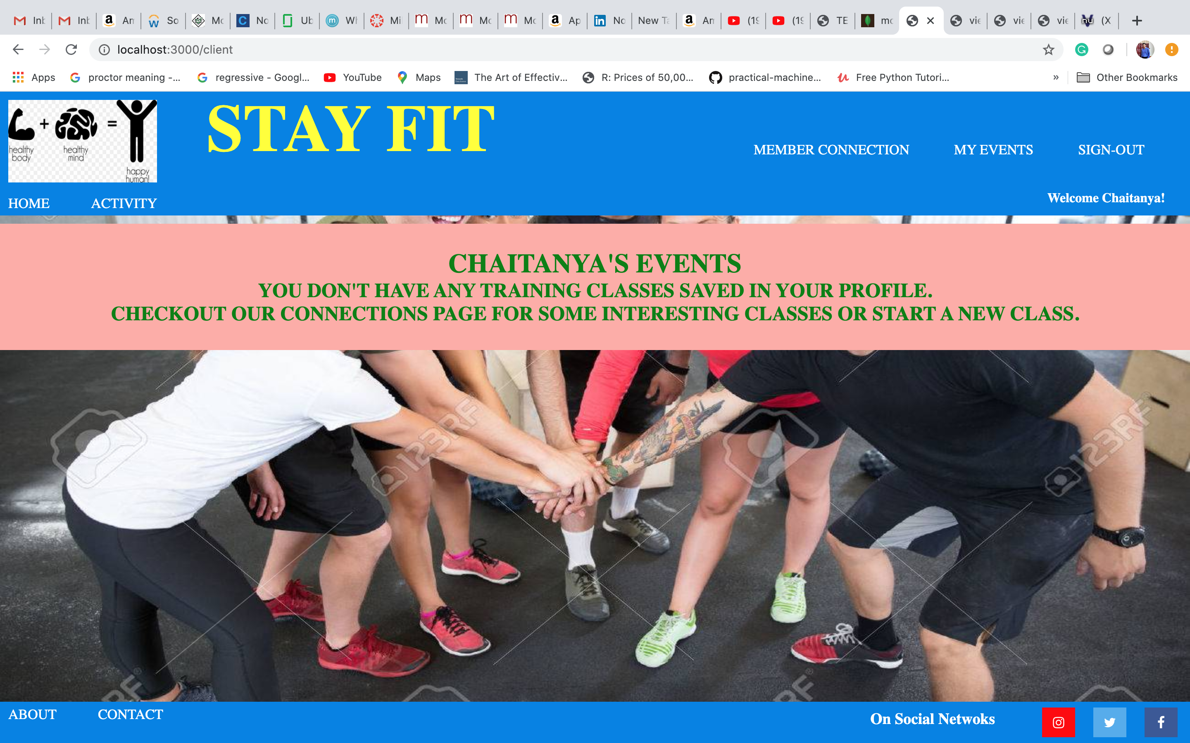

* **Classes (Events) Page**

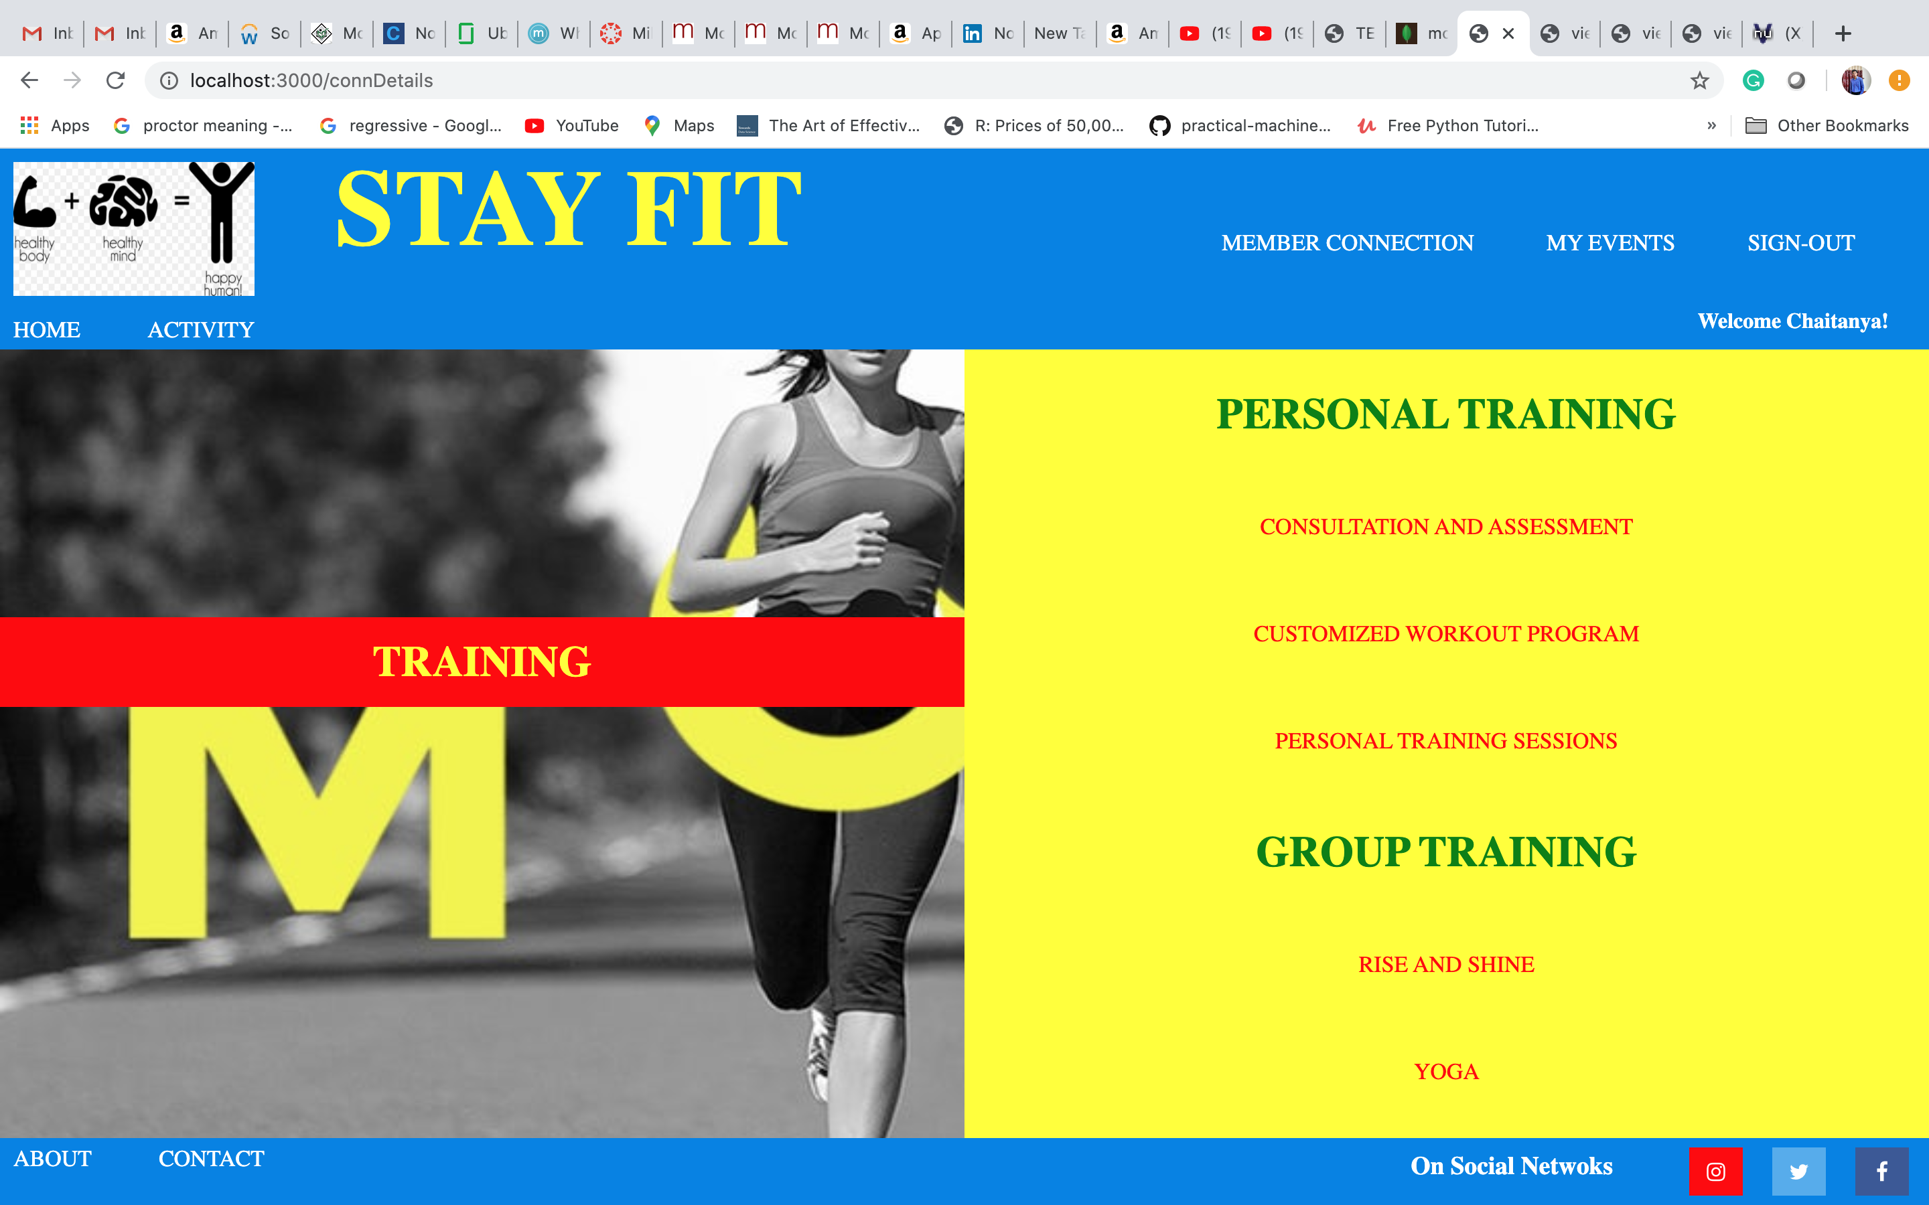

* **Class Detail (Event Detail) Page**

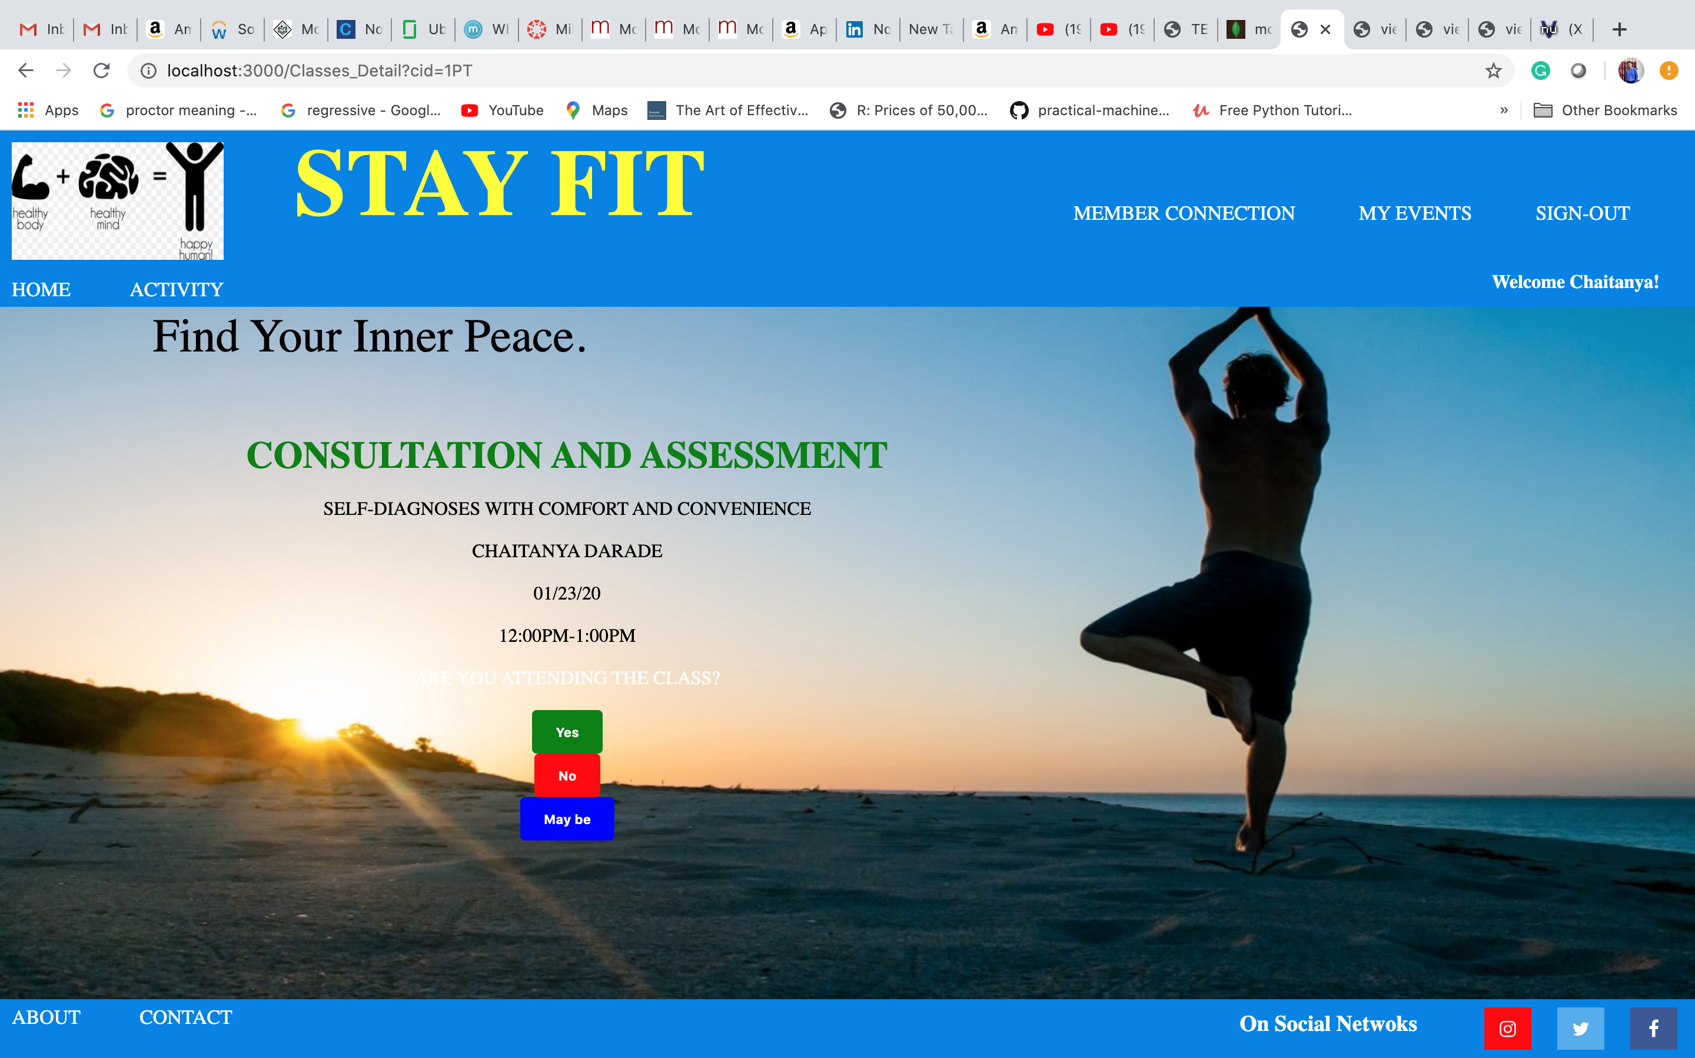

* **Events page (Going - YES)**

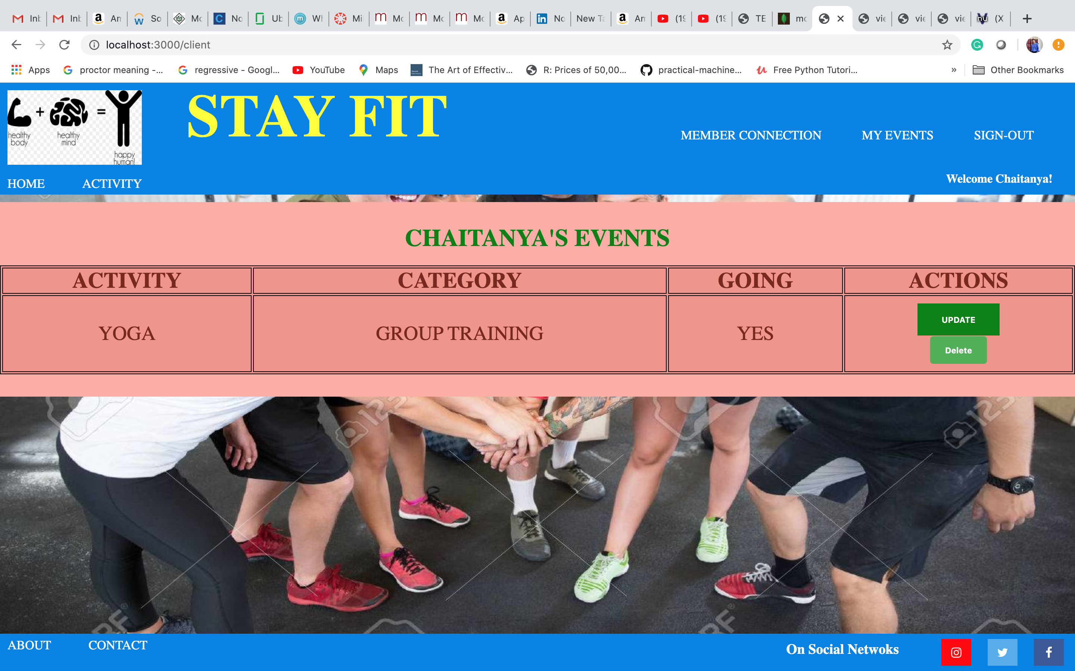

* **Updated Events Page (Going - NO)**

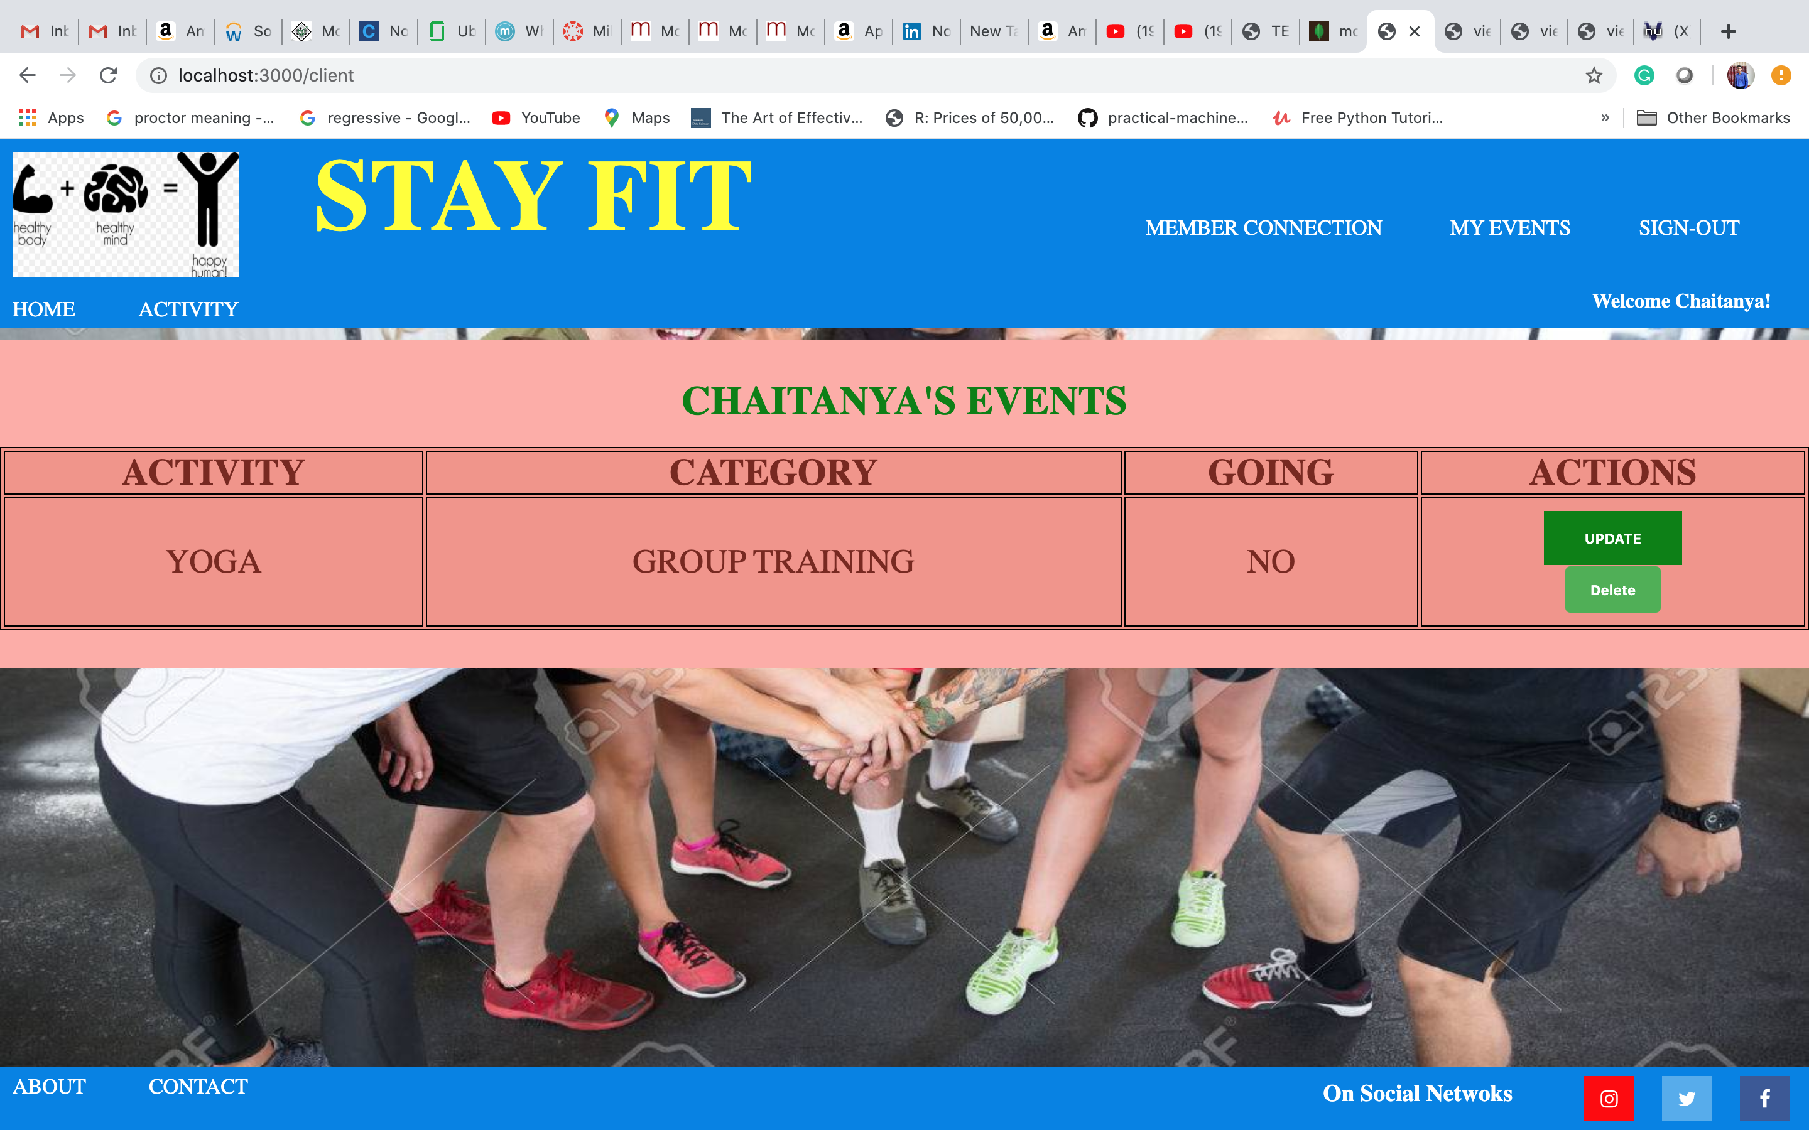

* **Updated Events Page (Added Connection – Consultation and Assessment)**

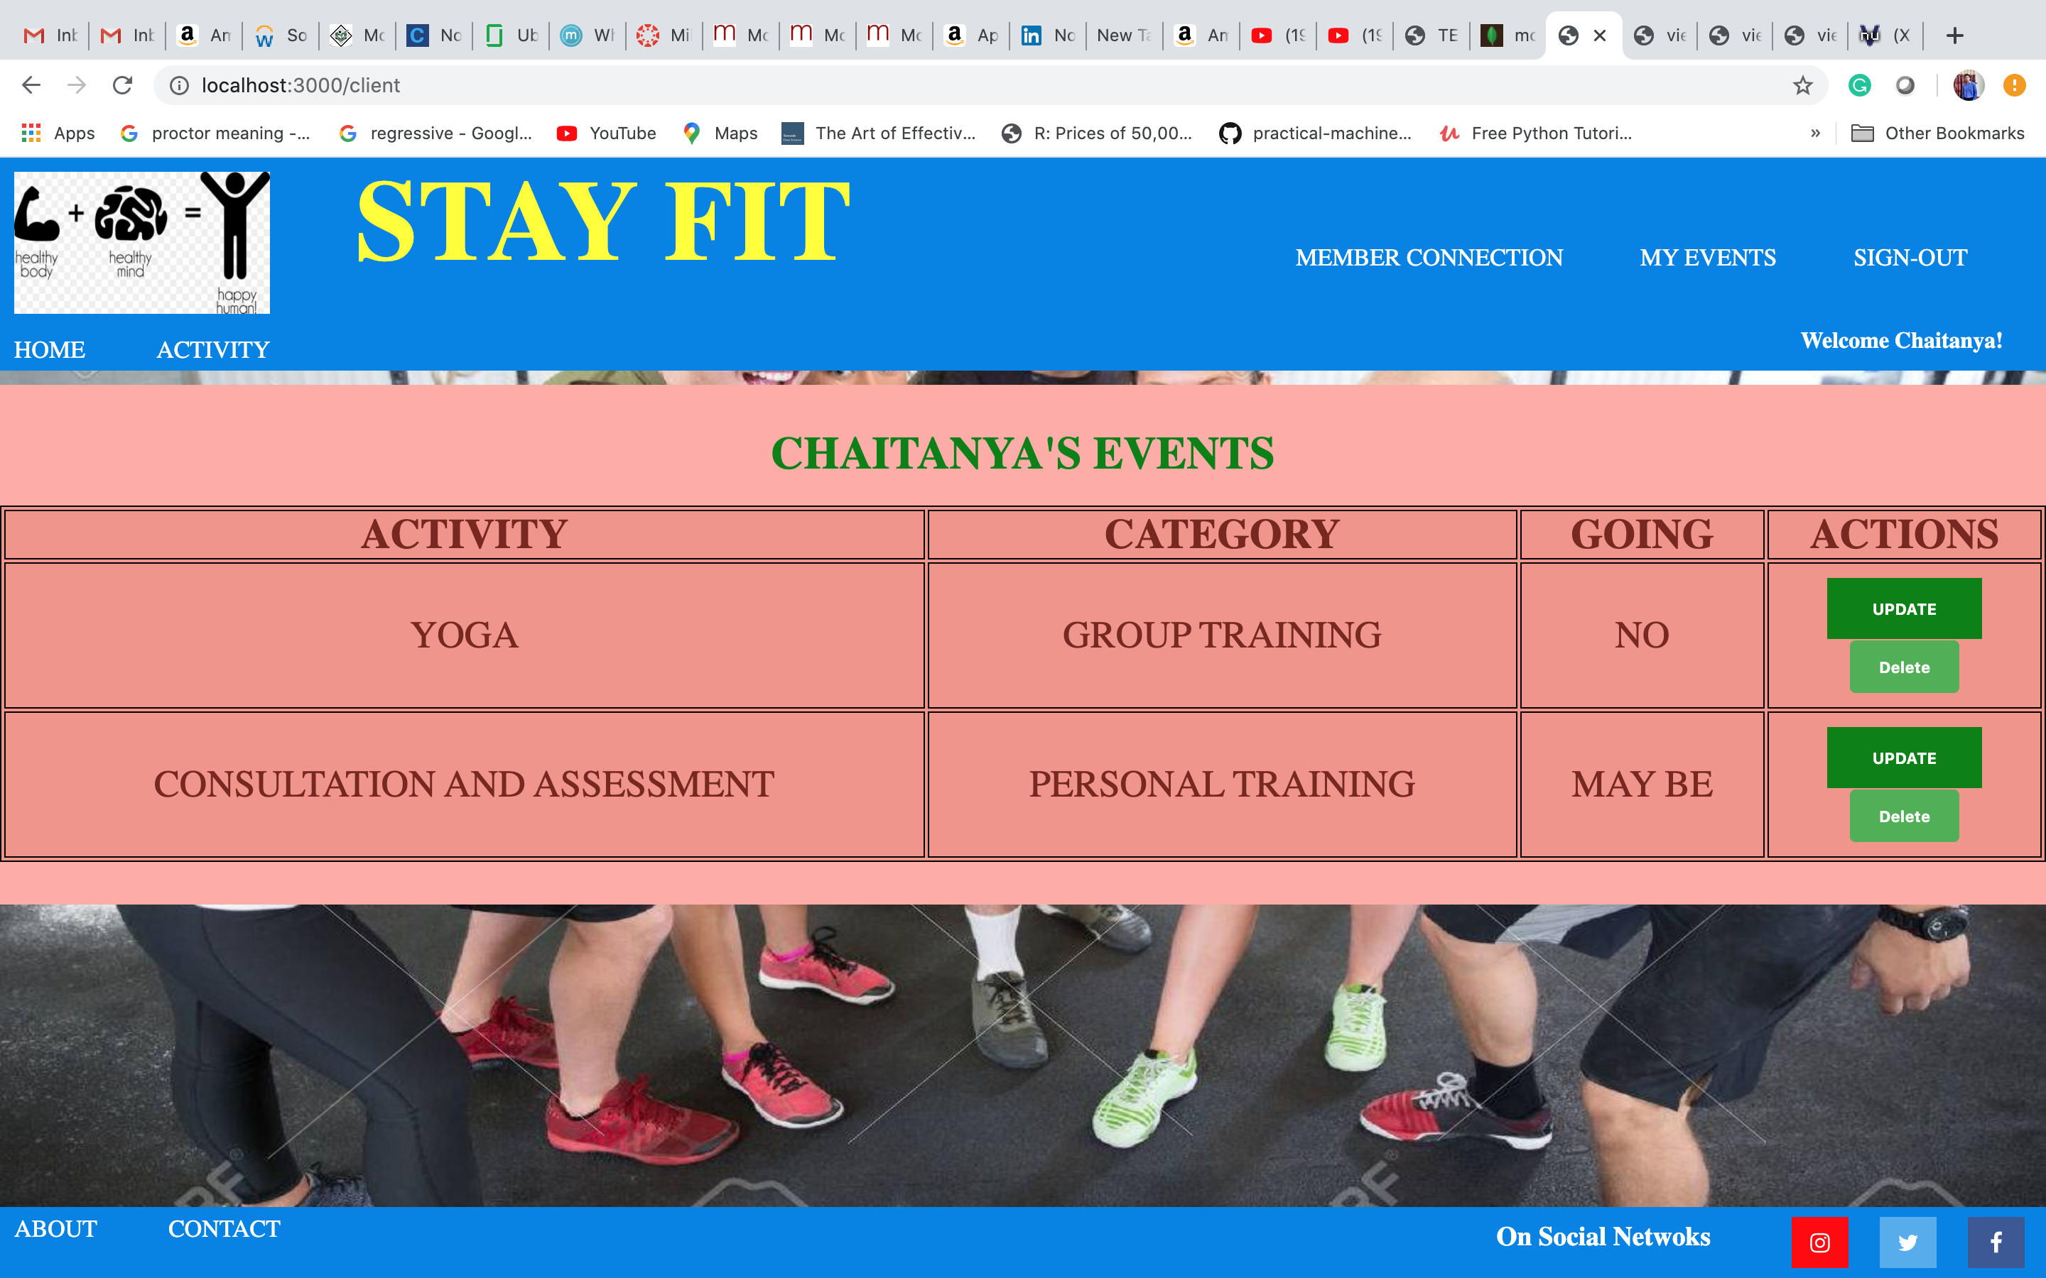

* **Updated Events Page (Deleted Connection – Yoga)**

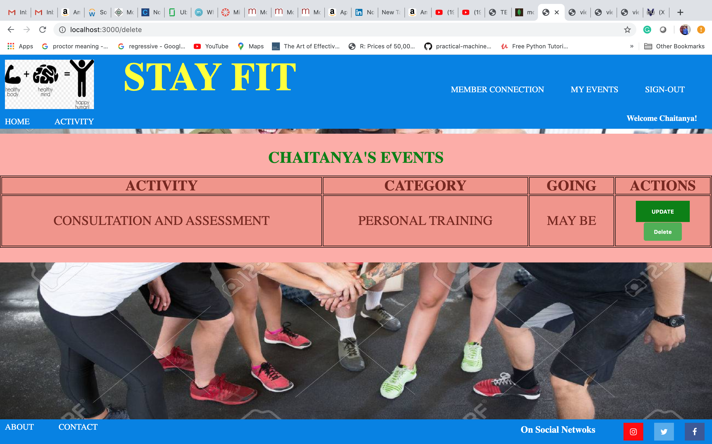

* **Updated Events Page (Deleted All Connections)**

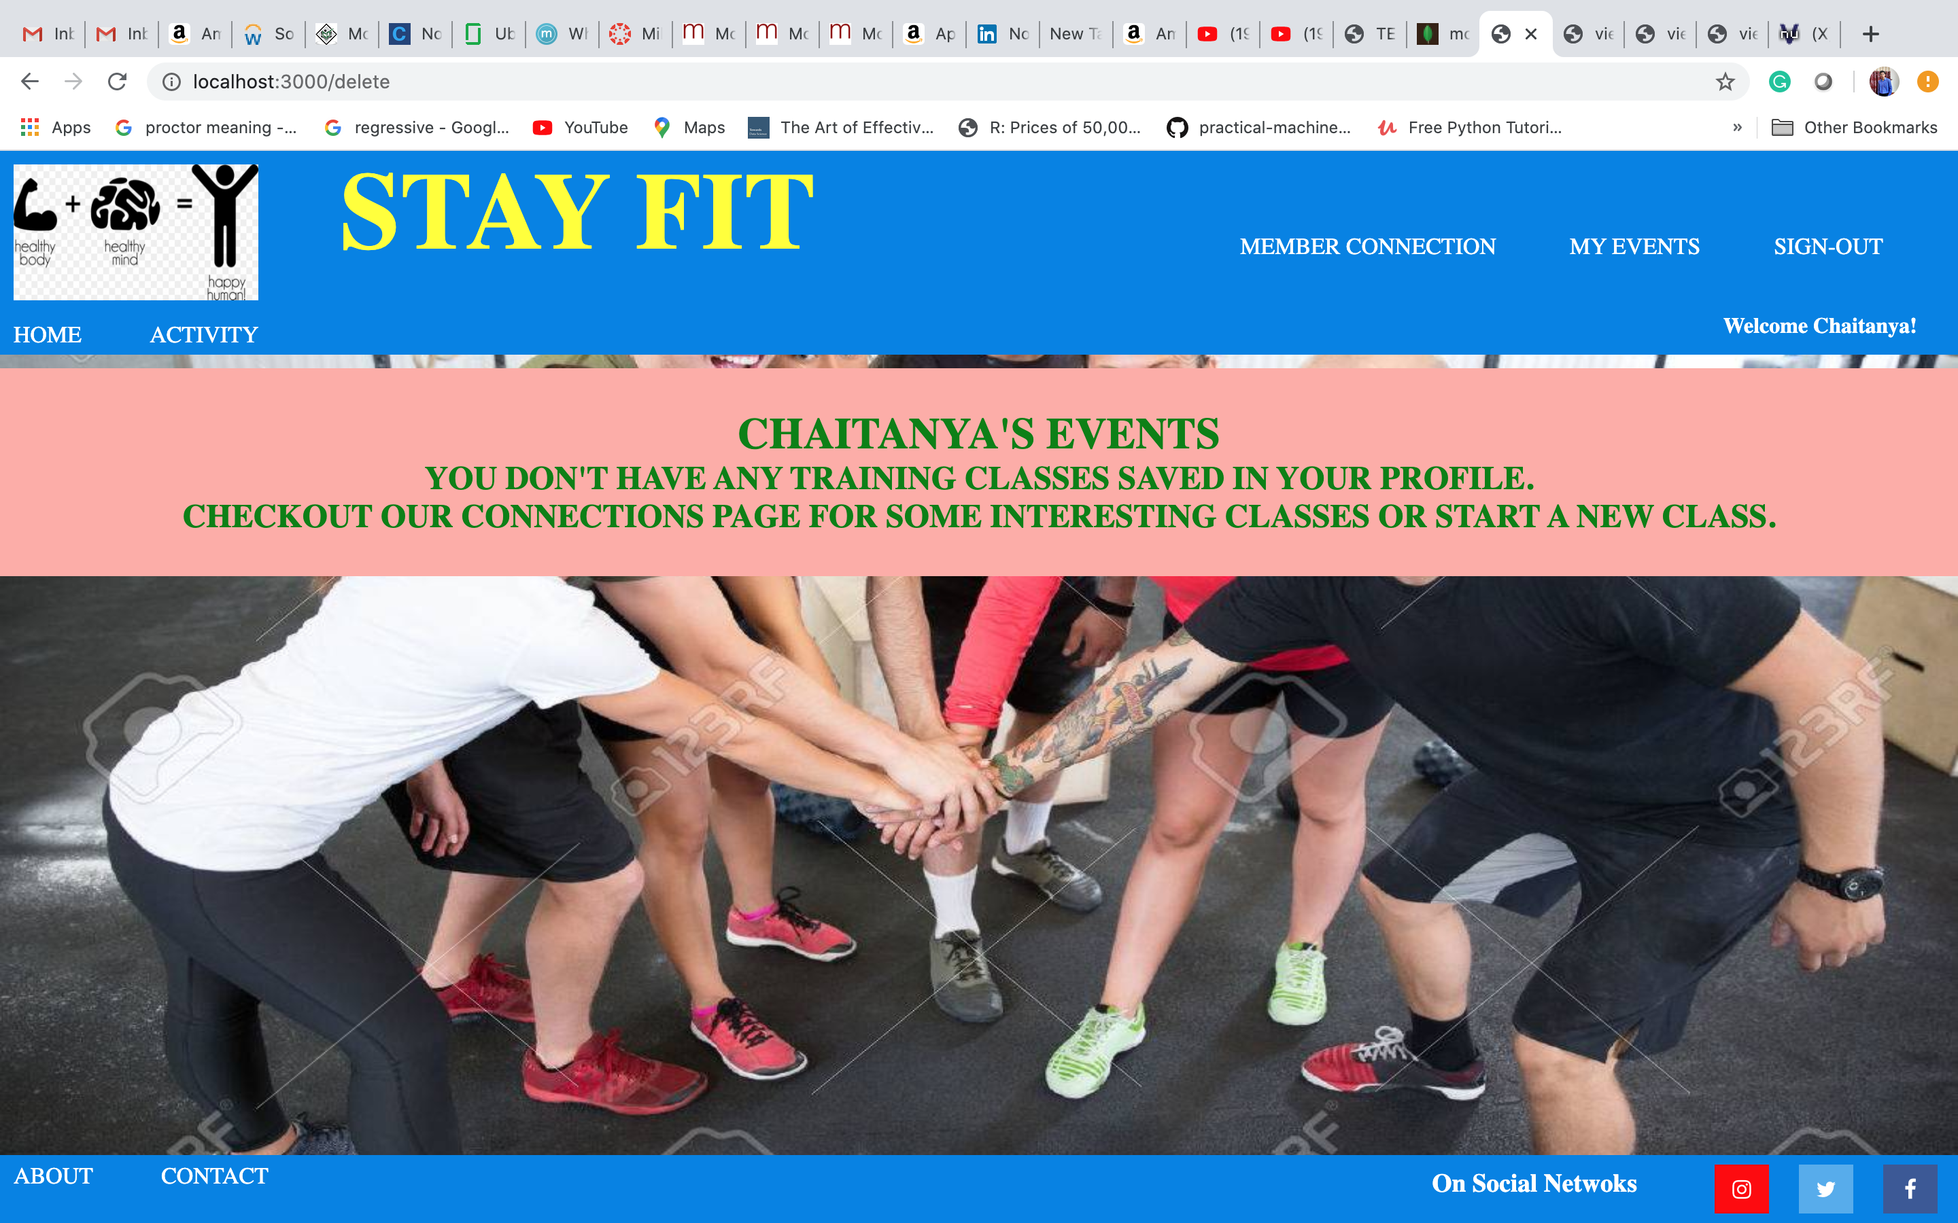

* **New Member Connection**

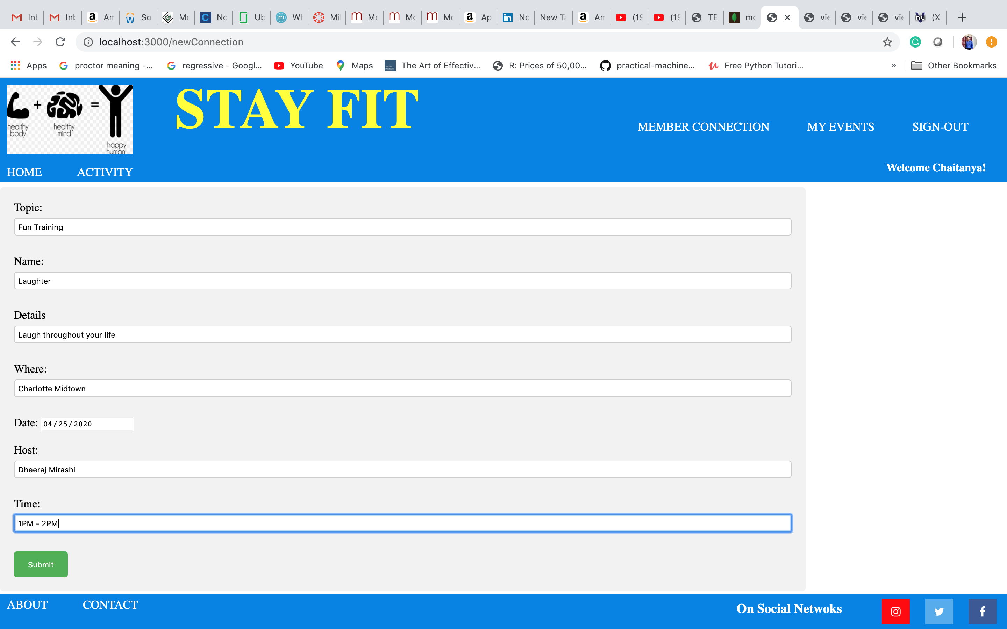

* **New Member Connection Added in Upcoming events**

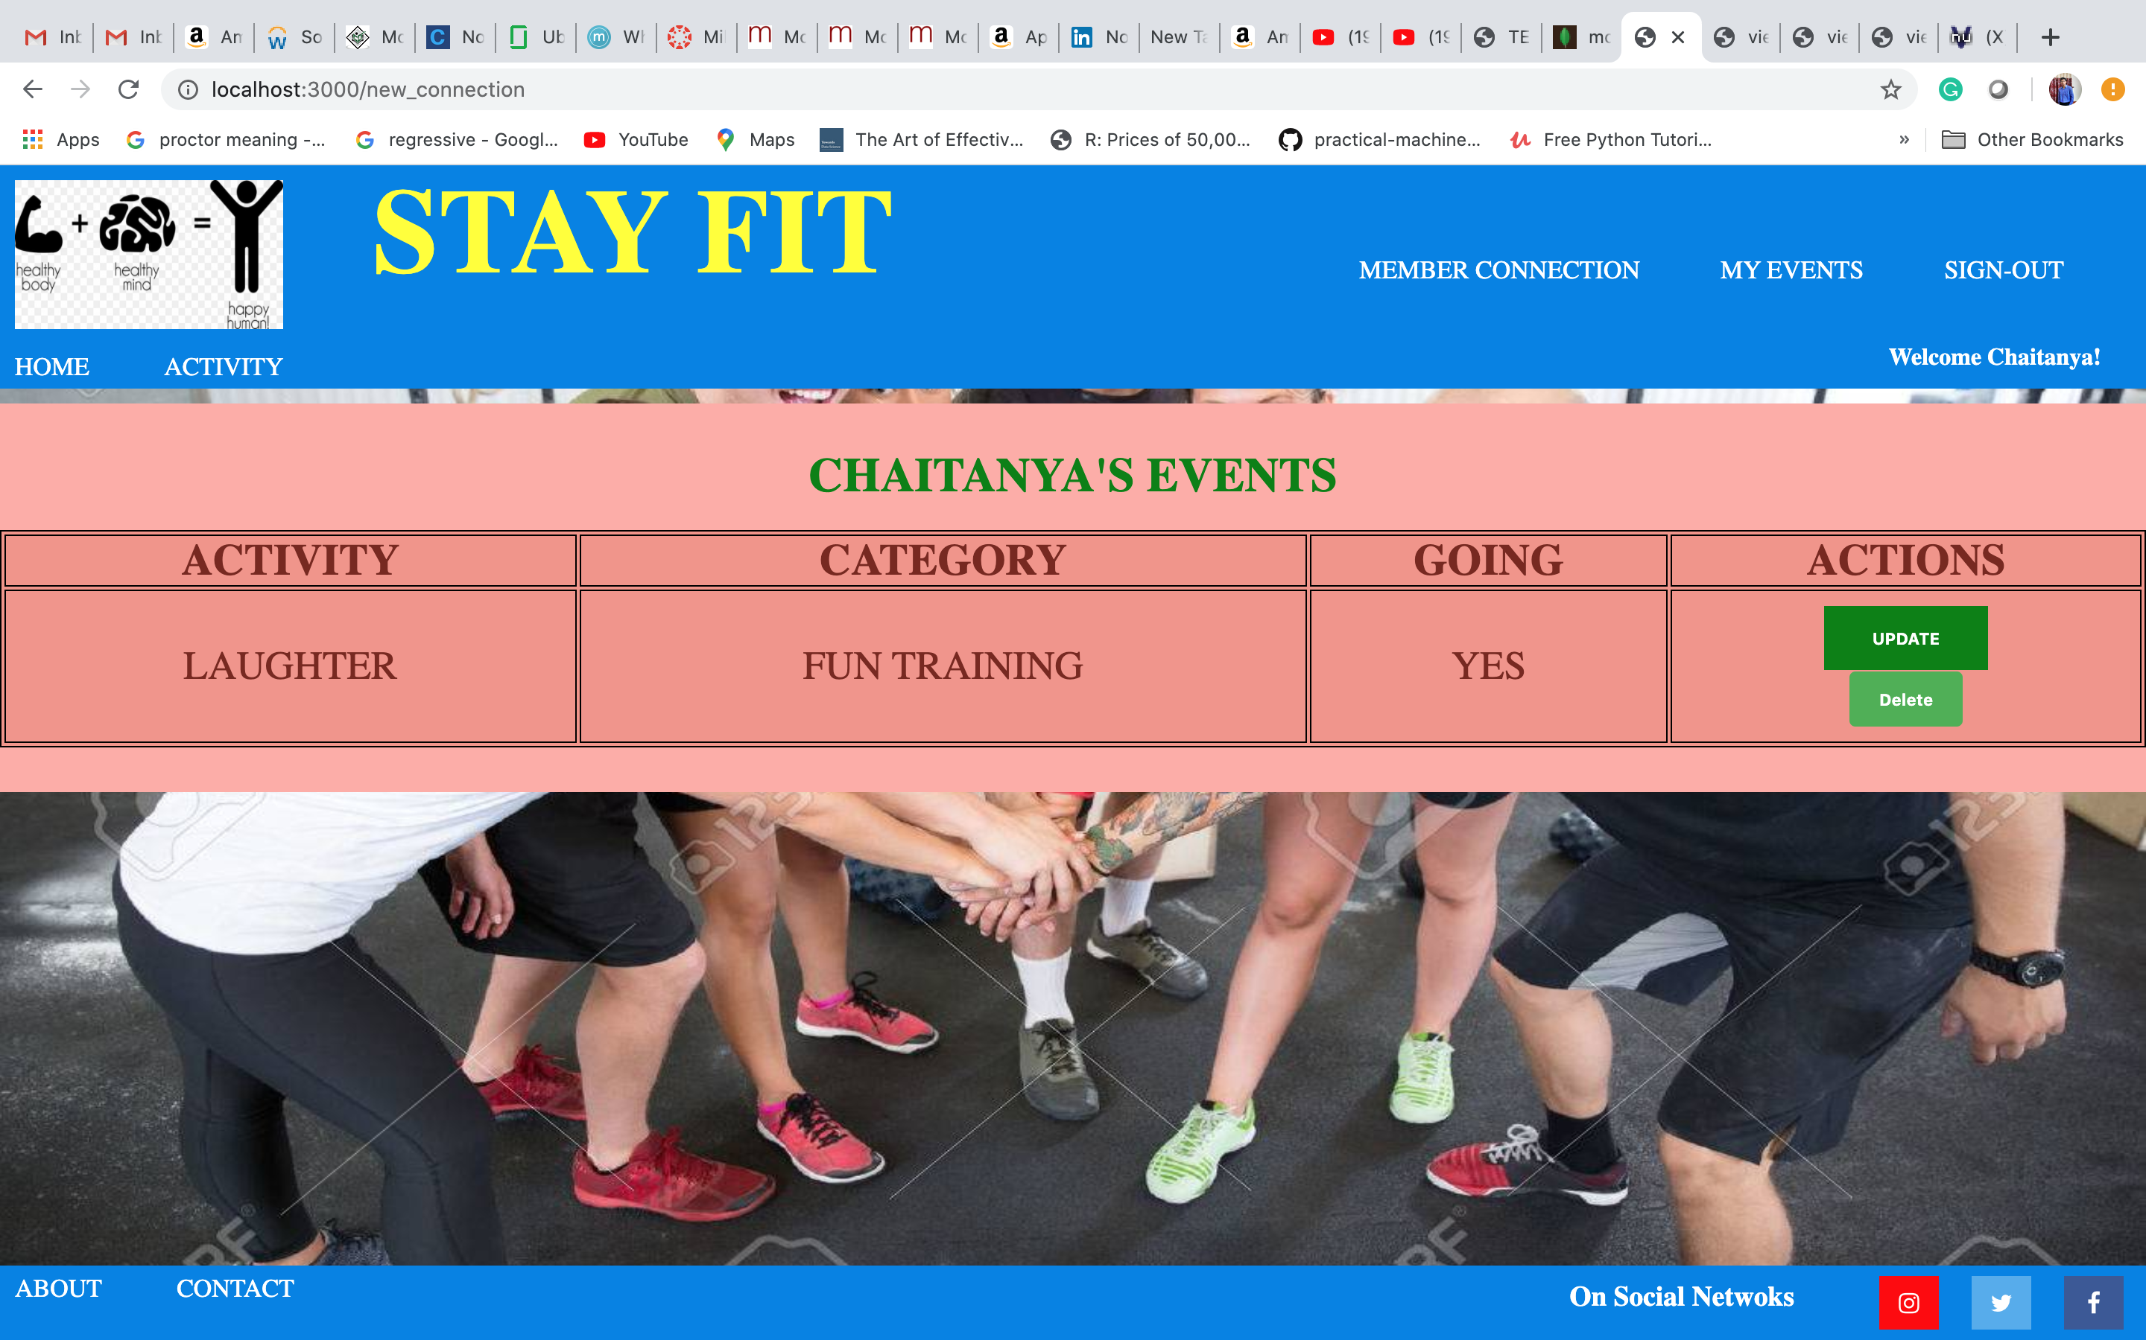

* **New Member Connection Added in events**

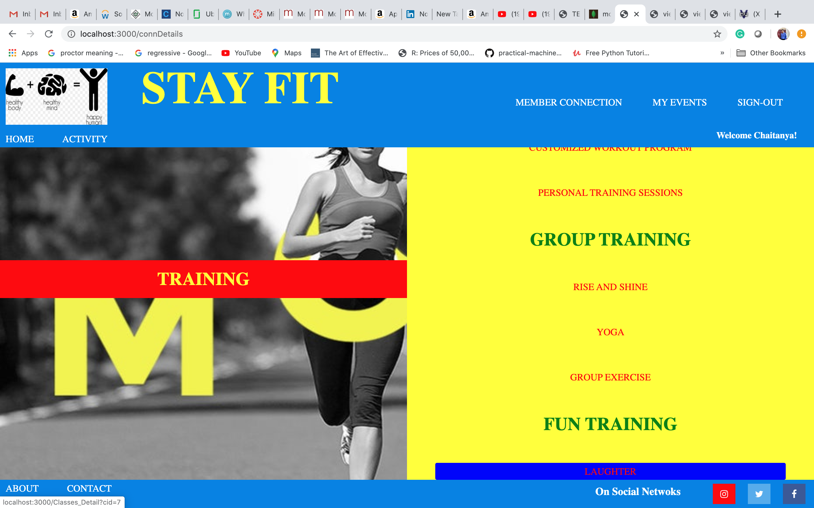

* **New Member Connection Added Details**

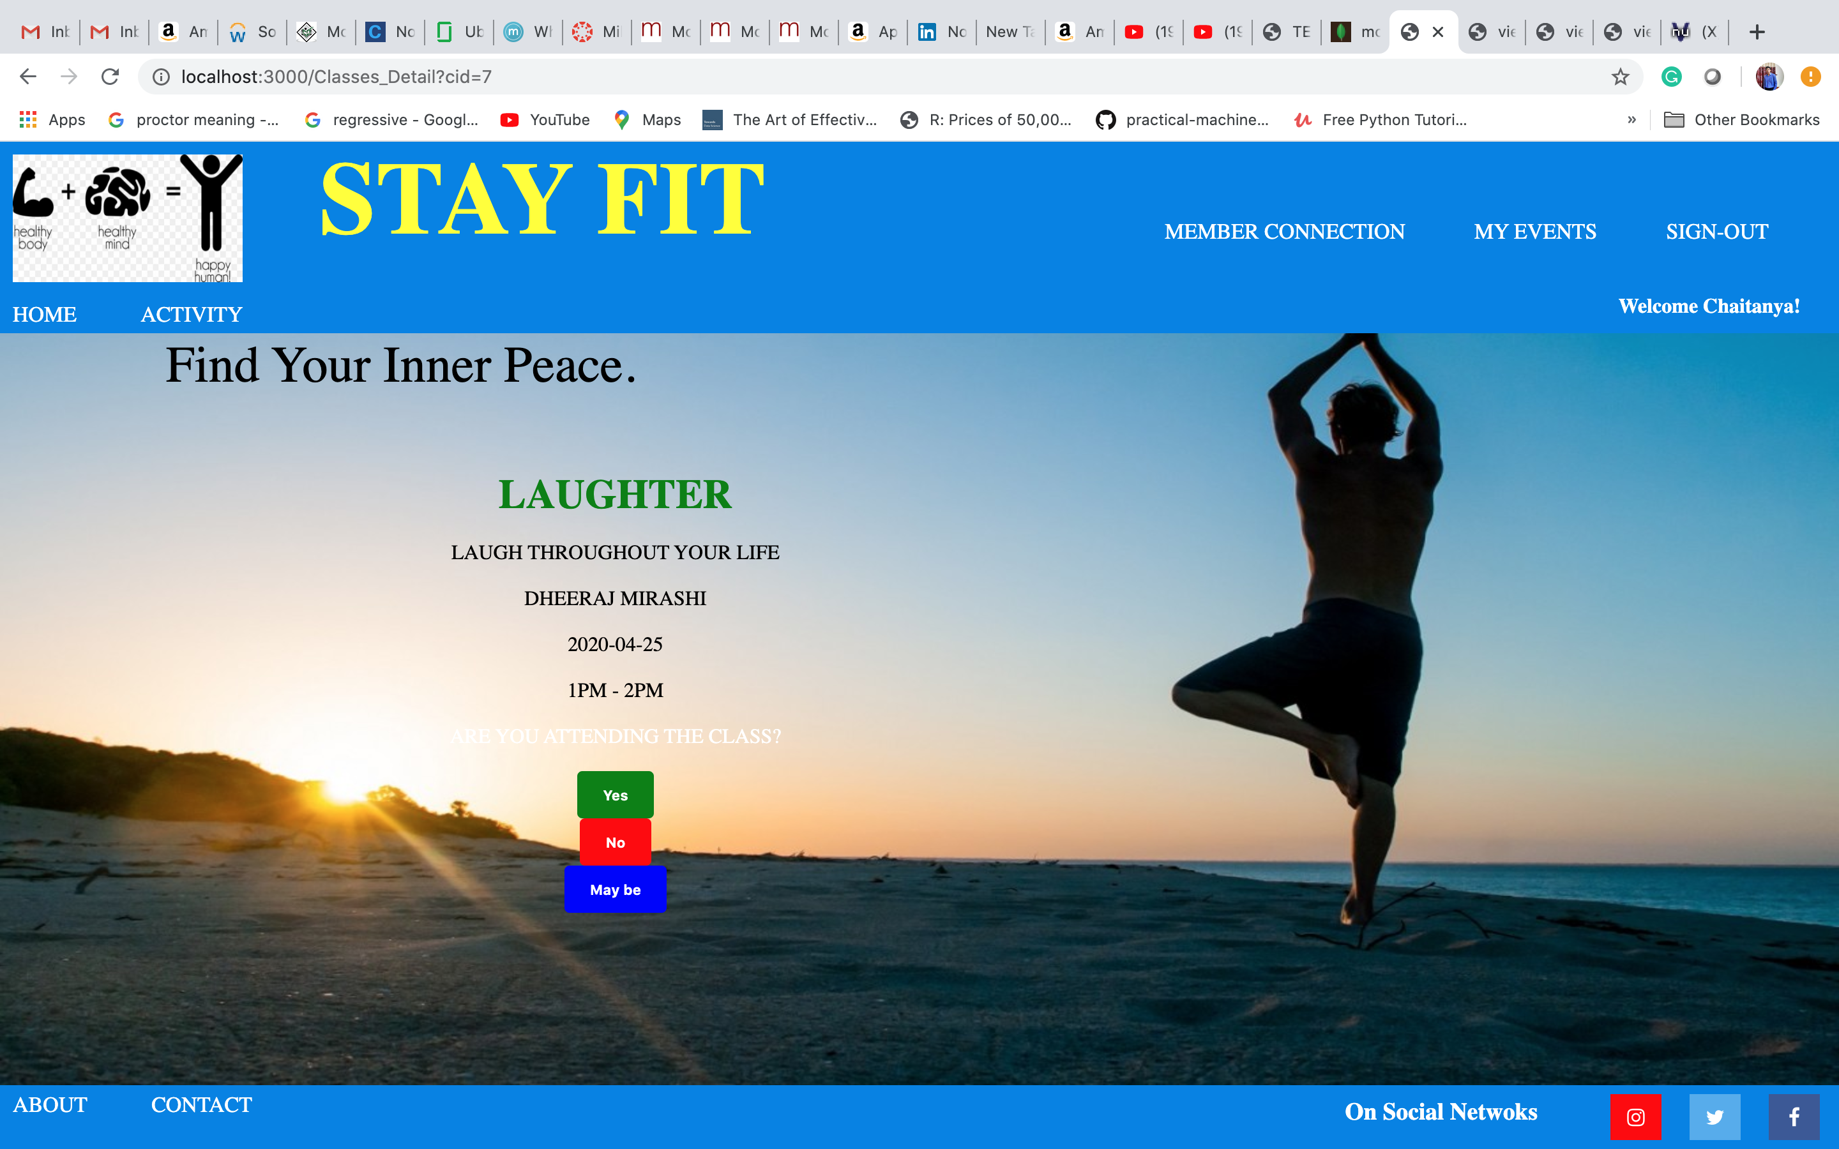

* **Delete newly added member connection as a creator**



* **Deleted newly added member connection from events page**

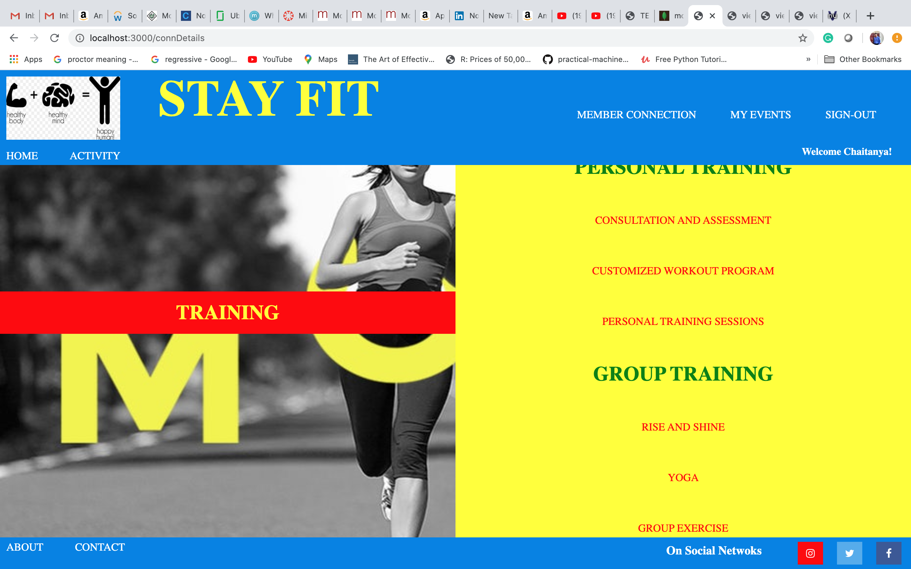

* **Profile Page (After SIGN-OUT)**



* **Cross Browser Functionality**

1. **Connection added on chrome and login page on safari**

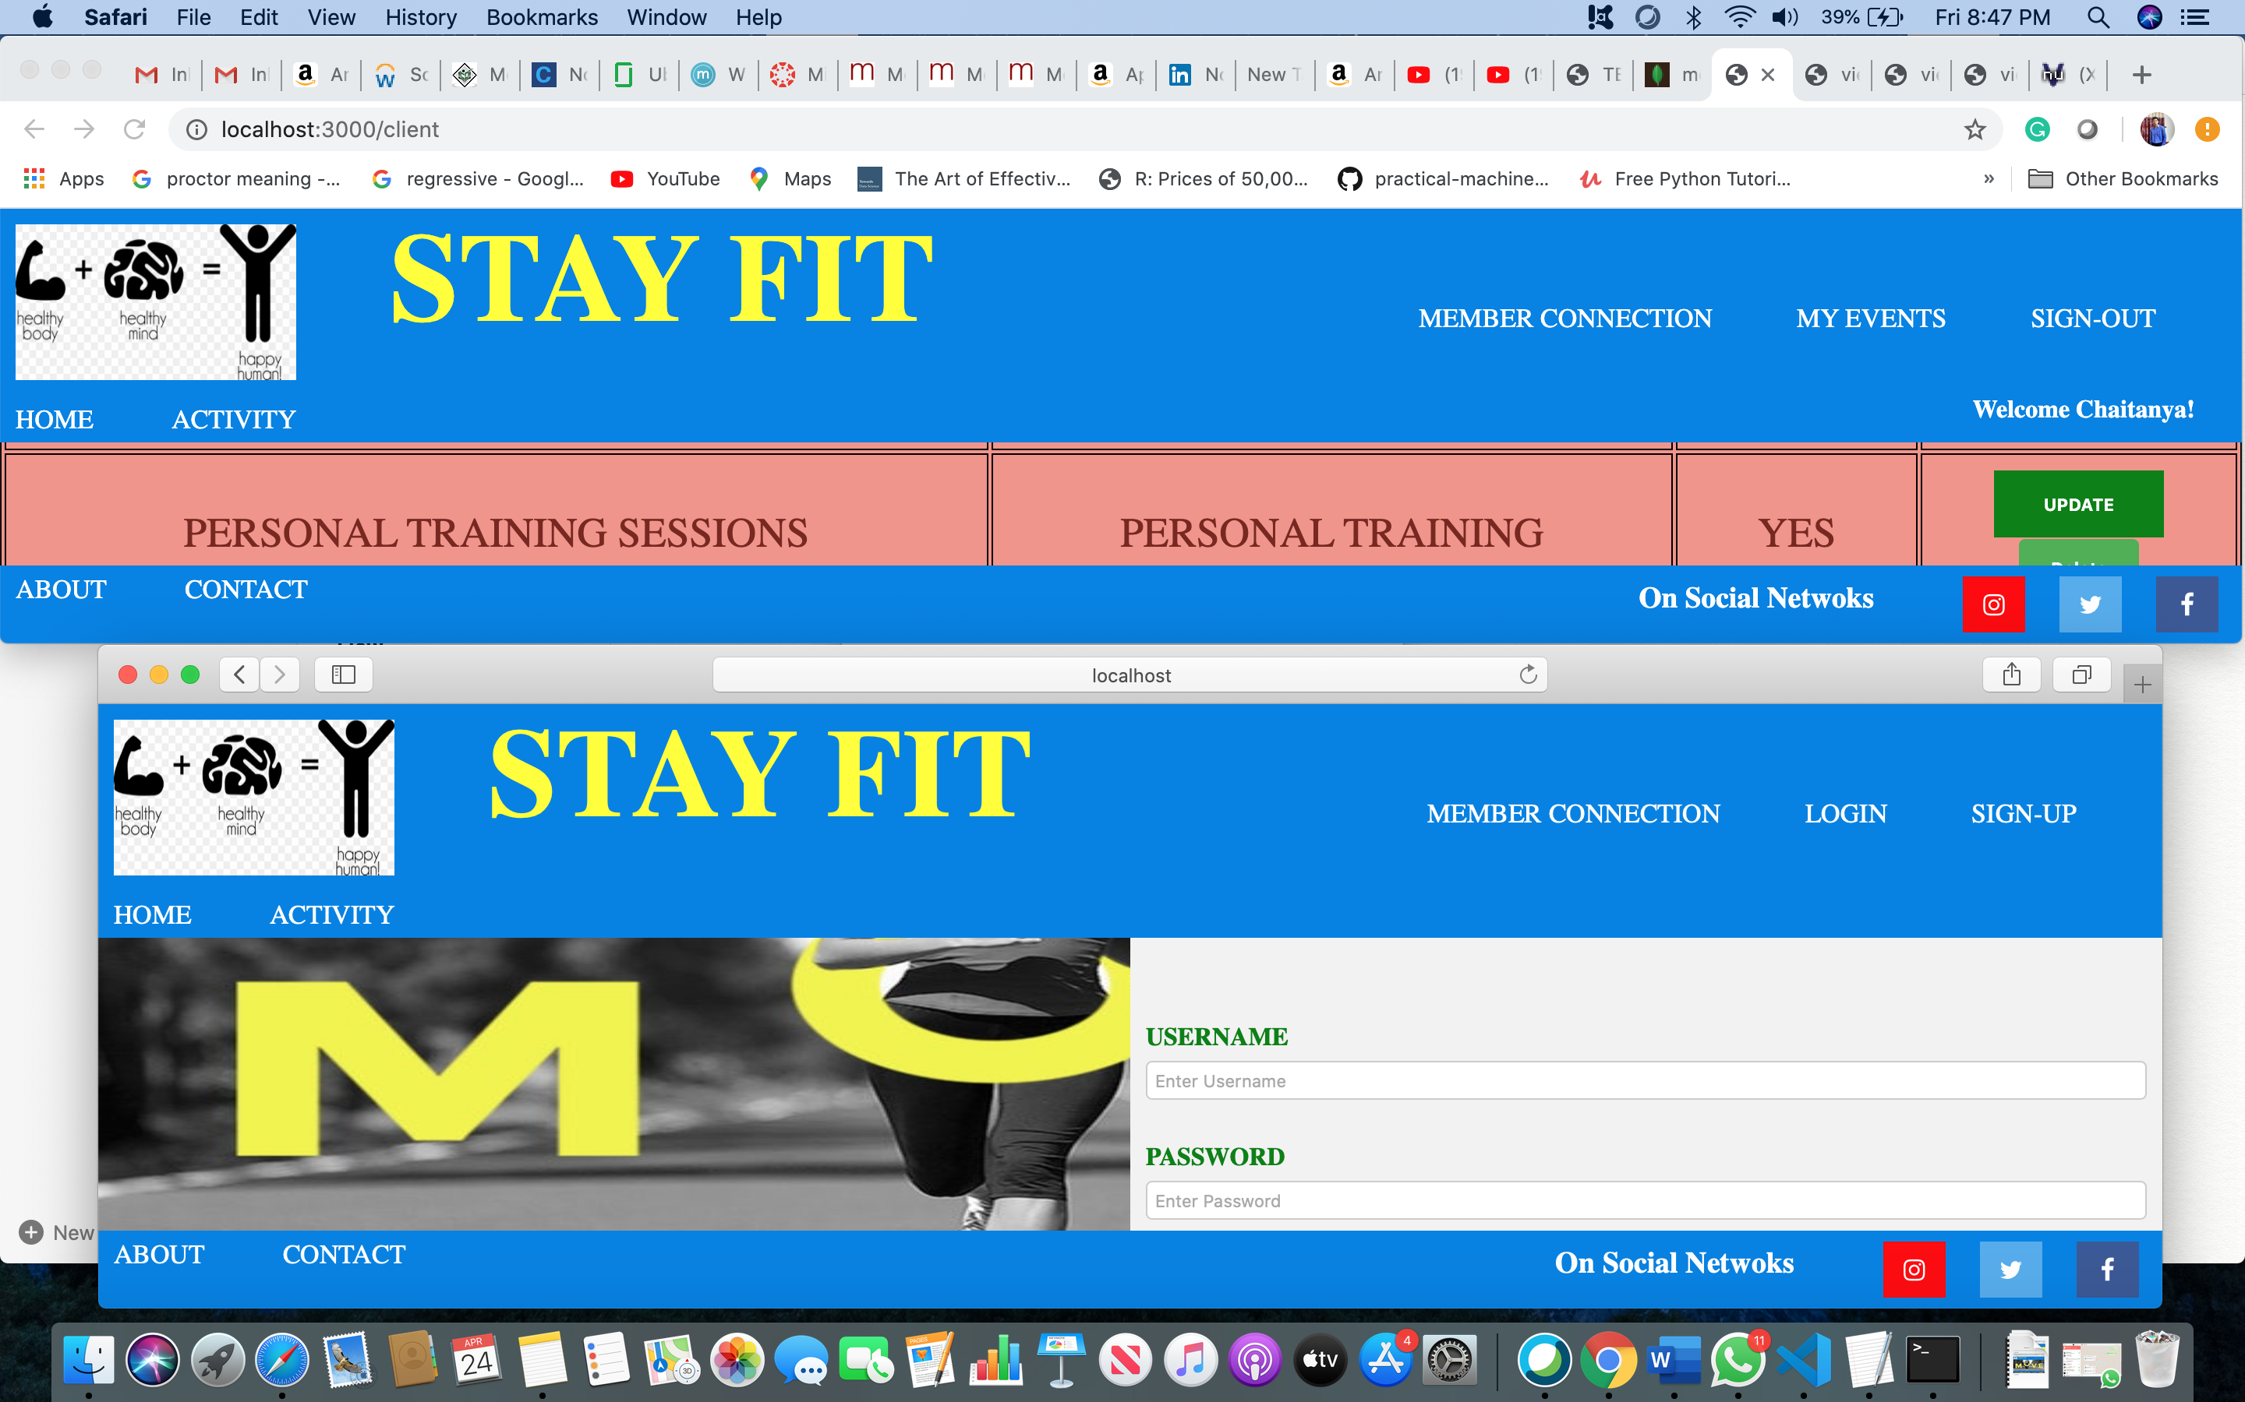

1. **Connection deleted on chrome(deleted from safari as well)**

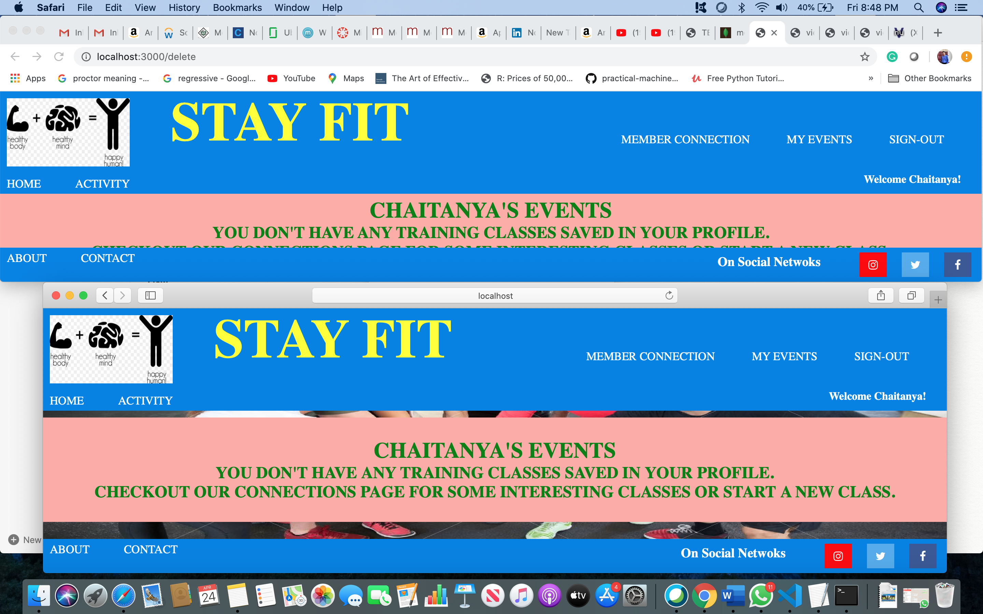

1. **Connection Added on Safari**

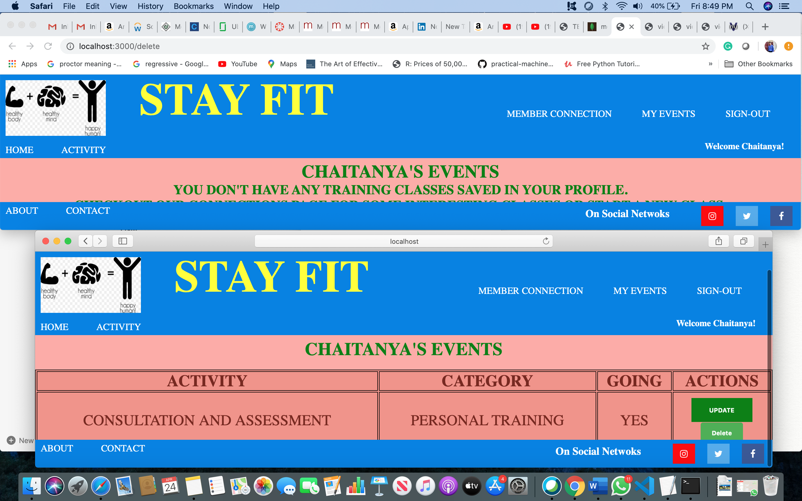

1. **Connection Shown in Chrome as well**

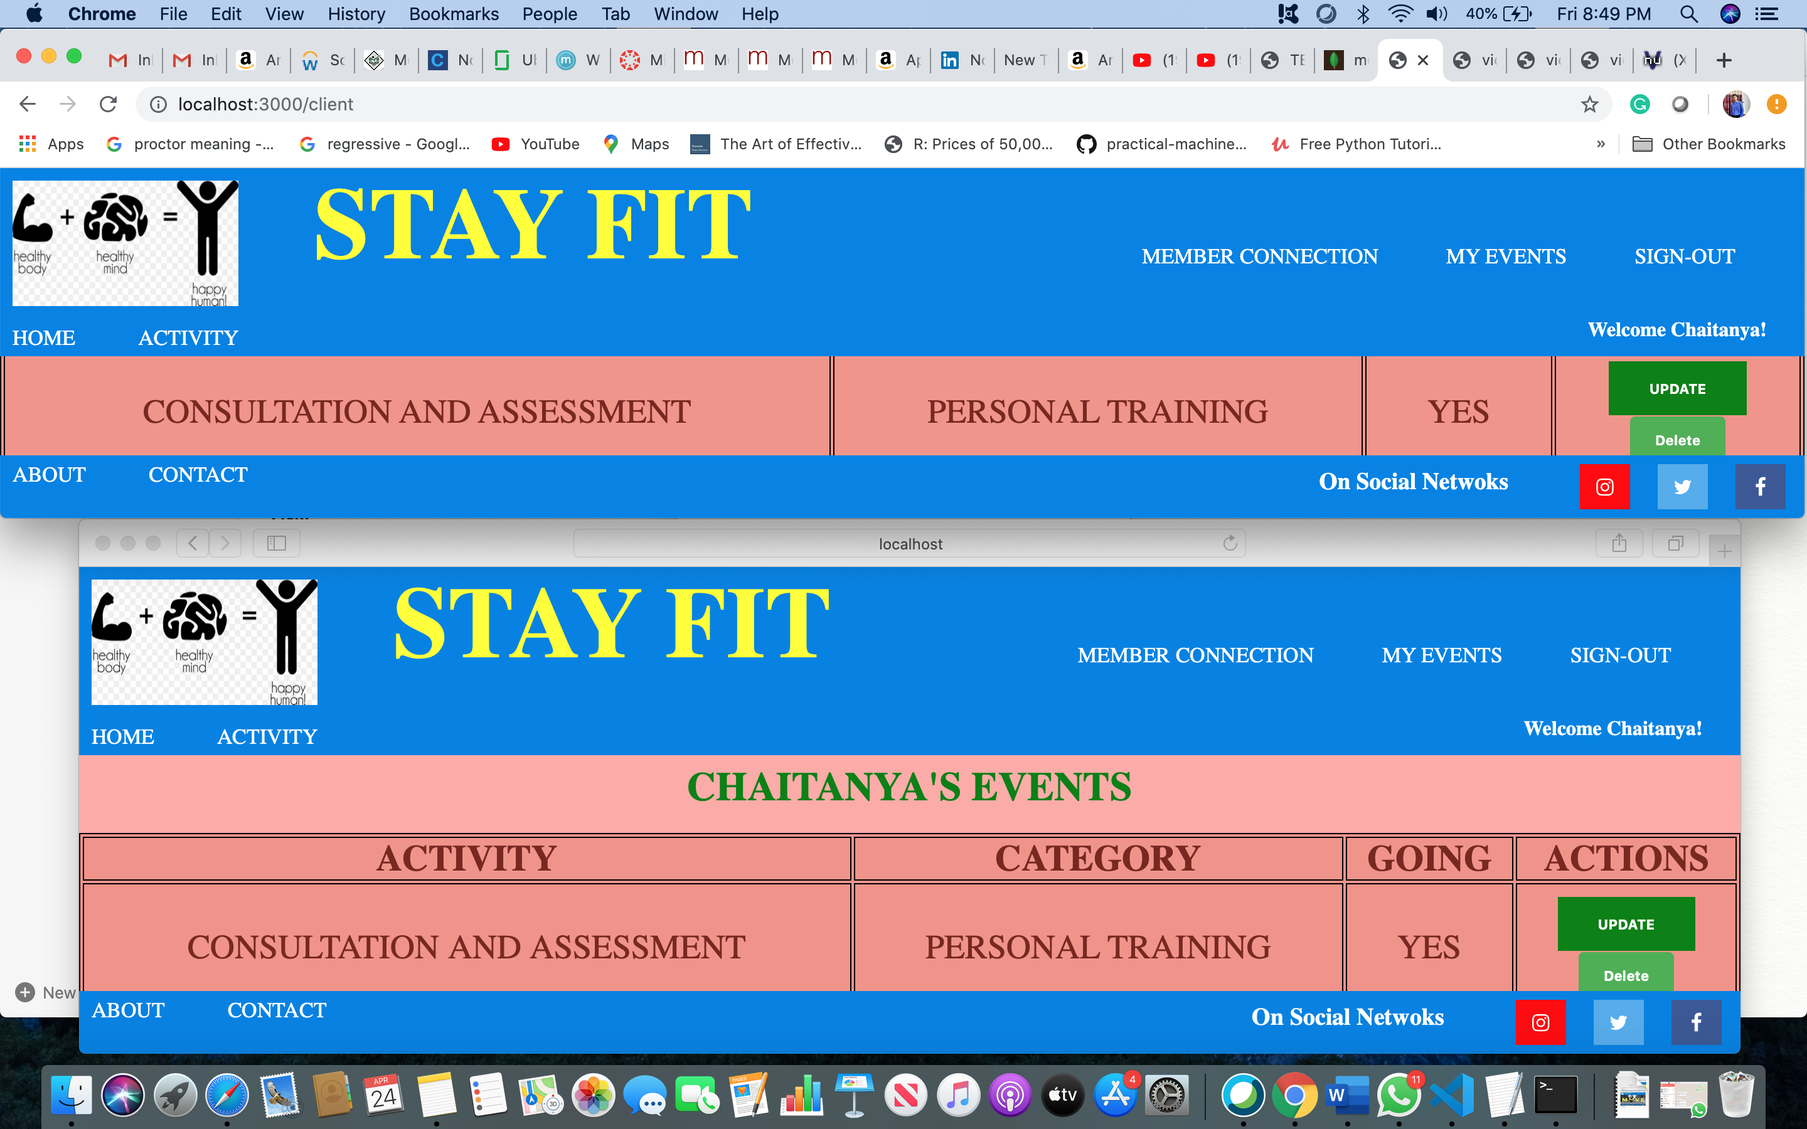

1. **Session Out (Logout) on Safari**

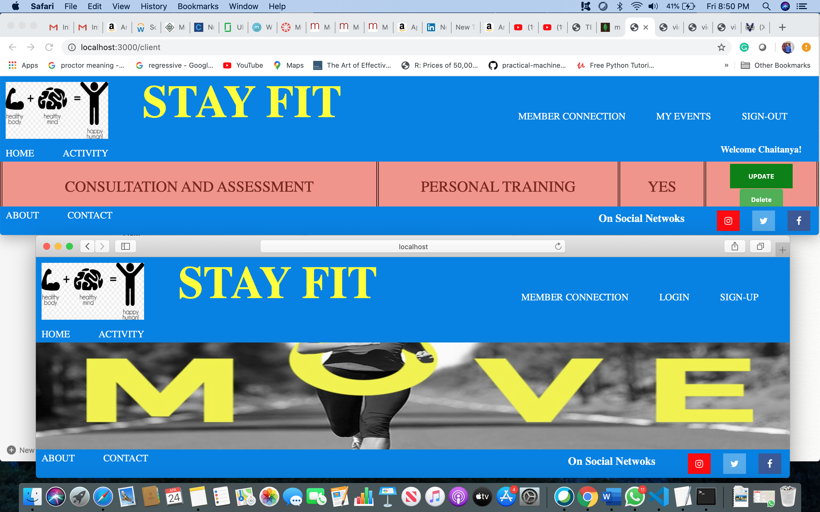

1. Discuss the easy and challenging parts of the milestone. How did you overcome all or some of the challenges?

**Answer:**

Challenging part was handling button click events (Yes, No, Update, Delete) within the same session using MongoDB.

Database population part was pretty straight-forward. However, I faced challenges mostly in handling async and await events, as my flow was not properly executed initially. Once I resolved the issue by understanding its exactly its working I could properly write and execute my code.